Chrome Extension Local Deployment Guide
Local setup and deployment steps for ChromeOS and Chrome Browsers
Part 1: Extracting 'chrome.zip' on ChromeOS
- Open the Files App: Launch the system launcher and click the blue folder icon to enter the native storage directory.
- Ensure your chrome.zip archive is situated explicitly under the My files -> Downloads path on the left sidebar context menu.
- Extract the Extension Package: Right-click (or tap synchronously with two fingers on your trackpad) the target archive file. Select Extract all from the context menu layout.
+----------------------+
| Open |
| Open with... |
| **Extract all** <-- CLICK THIS TO GENERATE EXTRACTED FOLDER
| Share |
+----------------------+

Upon decompression completion, a local directory structural layout named 'chrome' will be created at the root level of your local Downloads space.
Part 2: Loading the Unpacked Directory Into Chrome
- Navigate to the Extensions Suite: In a new tab, navigate directly to chrome://extensions. Alternatively, hit the Puzzle Piece toolbar widget and select 'Manage Extensions'.
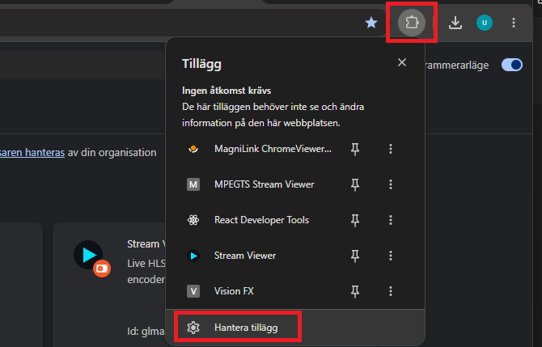

- Authorize Developer Privileges: Locate the Developer mode toggle switch in the far upper-right corner and shift it to the On position.
- Activating developer privileges triggers the immediate display of a secondary horizontal developer-centric control ribbon. Click on the Load unpacked button.
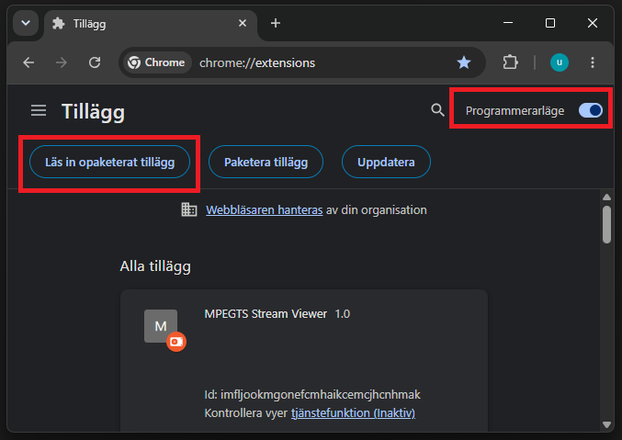

- A file selector portal will prompt for inputs. Traverse the tree to your local path and single-click the unzipped root directory named chrome. Click Open or Select to bind it.
📁 My files
└── 📁 Downloads
├── 📁 chrome <-- CHOOSE THIS UNZIPPED LOCAL DIRECTORY
└── 🤐 chrome.zip

