FeatherPRO Featherboard 
OWNERS MANUAL:
Bow Products FeatherPRO is designed to improve feed control, protect your wood and tools, and most importantly, to protect you better than plastic or wood featherboards. FeatherPRO feathers are made of durable High-Density EVA foam for a smooth firm glide, vibration dampening and are non-marring under tension. EVA will not harm cutters if contacted. Feather design features anti-kickback living hinge that absorbs kickback forces. EVA Feathers are reversible for left or right feeds or replaceable if damaged. You may opt to use our Ultralight Feather; Sold separately.
Fit Specification: Fits 3/8” x 3/4" (to 20mm) Miter Slots, T-Bolt fits 12-18mm T-Track (T Bolt spec: 5/16-18 x 2 1/4” Fully Threaded; Head Dim: .090 Thick x .45W x .725L)

FeatherPRO Part# FP1  Components | 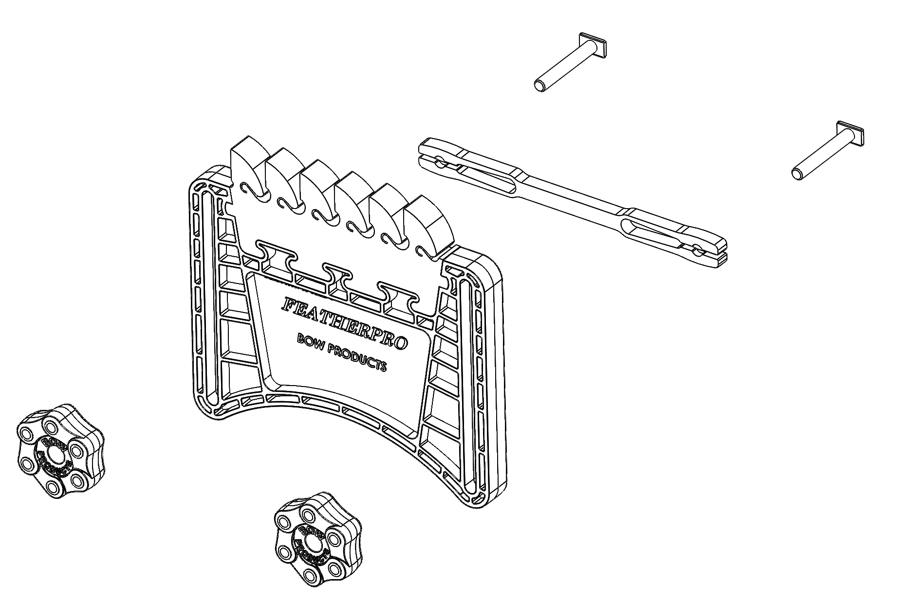  ASSEMBLY:  When using Miter Slot: Insert T-Bolts through Miter Bar (see image 1)  Next feed through the slots in the Plastic Body. Thread on Knobs.  When Using with T-Track: Assemble the same way, except leave out the miter bar.
  Plastic Body | 1
  ¾” Miter Bar | 1
  Knob | 2
  5/16-18 T Bolt | 2
  “Standard” EVA Feather | 1
  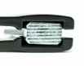 | 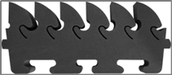
  Image 1 T-Bolt Nests | Image 2 Feed Direction

SET UP AND USE: Please read warnings below and study instructions prior to use. Mounts to a 3/8*3/4” (to 20mm) Miter Slot, or a 12-18mm T-Track. Assemble FeatherPRO for use in either a Miter Slot or a T-Track (see Assembly above). Position FeatherPRO with the Feathers in correct feed direction (see Image 2 above). After positioning FeatherPRO, apply desired tension and secure tightening both knobs.
Recommendations for use by machine type:
- TABLE SAW or BAND SAW: Position FeatherPRO on the table at least 1” forward of the cutter in the direction of the feed. WARNING Do not position the FeatherPRO after (outfeed) the cutter on the table saw table, doing so may pinch material against the cutter and cause kickback resulting in serious personal injury. You may position the FeatherPRO before or after the cutter on the table saw fence since the force of the feathers is down on the material.
- ROUTER: You can position FeatherPRO on the Router and Router fence before and after the cutter. Do not position FeatherPRO vertically directly over the bit or horizontally directly to the side of the bit. Doing so may cause contact between feather and the bit.
WARNING: When using Electric Power Tools with the FeatherPRO, be sure to understand and adhere to the manufacturer’s operating instructions including the safety precautions contained herein to avoid possibility of fire, Electric Shock or Personal injury. Read and understand all FeatherPRO and Power Tool instructions before using this product.
WARNING: Always ensure the Power Tool is turned off during set up. A featherboard is not an anti-kickback device. Its purpose is to help feed wood through a cutting tool. Be sure that your material and fence are square as you cut and that you use a sharp cutting tool. Practice safe practices and keep hands away from the cutting tool edges and your body out of the cutting path. Keep hands clear of the cutter.
WARNING: California Prop 65: This Product may contain one or more chemicals known to the state of California to cause cancer and birth defects or other reproductive harm. For more information, go to www.P65warnings.ca.gov.

FeatherPRO ACCESSORIES:
- Ultralight Replacement Feathers (Pt # FPU2): Feather designed for greater sensitivity and control of feather flex.
- Standard Replacement Feathers (Pt # FPS2): Standard Replacement feathers that come with the FeatherPRO.

Other Bow Products: FeatherDUO Featherboard; GuidePRO and GuidePRO Accessories, PushPRO Push Stick and Hardware Kits. See Website

WARRANTY: One Year Limited warranty for Defects in Materials or Workmanship.
CUSTOMER SERVICE: You may contact us via customerservice@bow-products.com. You may also contact us at 844.895.4488.

Bow Products Inc. 8778 Boyce Rd. Corfu, NY 14036 PH: 844.895.4488 www.bow-products.com May 2020

